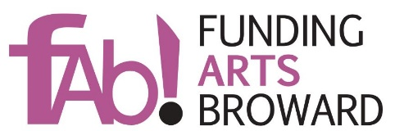
October 2019
RE: FUNDING ARTS BROWARD’s - FAB! 2021 GRANTS
“Funding Arts Broward supports, sustains and enriches the arts in our community.” FAB is excited to announce the opening of our 2021 Grant Season as one of many efforts FAB puts forward to live our mission every day.
Applications for Funding Arts Broward’s - FAB! 2021 Grants are available online as of Thursday, October 3rd, 2019 at www.fundingartsbroward.org. The deadline for FAB! 2021 Grant Submissions is Friday January 24th, 2020 at 10:00 PM.
FAB! 2021 Grants to eligible organizations will be awarded in amounts as follows:
- Organizations with annual budgets over $1 million may be awarded a FAB! 2021 Grant for $5,000 to $15, 000.
- Organizations with annual budgets under $1 million may be awarded a FAB! 2021 Grant for $5,000 to $10,000.
- Organizations with annual revenue under $100,000 may be awarded a FAB! 2021 Grant for $2,000 to $5,000. Recognizing that small and emerging arts organizations are often the breeding ground for new and innovative programs, the Board of Directors of Funding Arts Broward has created this third tier for our FAB! 2021 Grants cycle.
IMPORTANT: Submissions for FAB! 2021 Grants must be specific project/program oriented, so applicants must describe in detail, the specific project or program, for which they are applying for funding. The FAB! 2021 Grants Committee will not consider entire seasons for funding, even when the entire season is a cohesive series of programs.
Remember, applications will be considered based on your organization’s compliance with the FAB! 2021 Grant Application Instructions, found on our website: www.fundingartsbroward.org, and the quality and community impact of your program/project. Eligibility requirements for FAB! 2021 Grants are also found at www.fundingartsbroward.org.
As the FAB! 2021 Grants Co-Chairs, we invite your participation and want you to be successful in your application for a Funding Arts Broward’s FAB! 2021 Grant. If you have questions about the application process or instructions for completion, please direct them to fabgrants@gmail.com. We look forward to receiving your application.
Sincerely,
Cindy Eden & Harvey Shapiro

