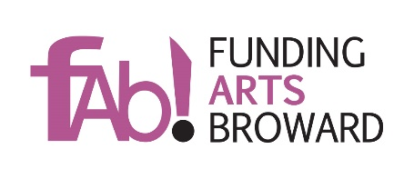

[Organization Logo]

MEDIA CONTACT:
Michael Goodman
GPR | Goodman Public Relations
(954) 446-0806
michael@goodmanpr.com

[ORGANIZATION] RECEIVES A GRANT FROM FUNDING ARTS BROWARD

FORT LAUDERDALE, Fla. (May 6, 2019) – [Organization] has been awarded a grant from Funding Arts Broward (FAB!), a non-profit arts organization committed to preserving and cultivating the arts in Broward County, Florida. This is one of 27 grants for 2020 awarded by FAB! that total $242,000.

“[Organization] is thankful for this generous support from Funding Arts Broward,” said [Name], [Position] of [Organization]. “These funds will allow us to present another quality program which we hope will educate, entertain and inspire the community.”

The [$ Amount] grant will be directly applied to our [Program Name]. [Insert Program Information.]

“FAB! is proud to support [Organization] as part of its mission to enrich the local arts community by funding the presentation of diverse programs,” said Carolyn Lee, president of FAB!. “[Organization] is a deserving recipient of this grant based on the impact that their artistic program will have on Broward County residents and visitors.”

For more information on the Funding Arts Broward including how to get involved, please call 954-353-7673, email fundingartsbroward@gmail.com or visit www.fundingartsbroward.org.

[Organization Boilerplate]

About Funding Arts Broward (FAB!)
Funding Arts Broward, (FAB!) is a non-profit volunteer-based arts organization committed to preserving and cultivating the arts in Broward County, Florida. FAB!’s mission is to enrich the local arts community by funding Broward County based visual and performing arts organizations that meet eligibility requirements and present high-quality programs to the public. Since its inception in 2003, the organization has granted over $3 million to local visual and performing arts programming.

# # #

